Dealer Tool Kit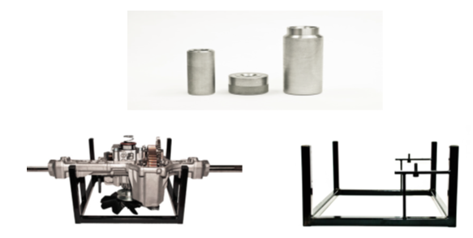
Pricing:
Complete Dealer Tool Kit – Part #8888 £135.45 net ea.
Inc. (Repair stand, small input seal install tool, ¾” axles seal install tool, 1” axle seal install tool

Individual Tools:
1111 – Repair Stand - £69.64 net ea.
2222 – Small Input seal installation tool - £15.16 net ea.
3333 – ¾” axle seal installation tool - £37.14 net ea.
4444 – 1” axle seal installation tool - £32.08 net ea.

